

Semester One Examination, 2021

Question/Answer booklet

MATHEMATICS  
METHODS  
UNIT 1

Section Two:  
Calculator-assumed

**Your name**

**Teacher (please circle)** HILL PECK

## Time allowed for this section

Reading time before commencing work: ten minutes

Working time: one hundred minutes

## Materials required/recommended for this section

***To be provided by the supervisor***

This Question/Answer booklet

Formula sheet (retained from Section One)

***To be provided by the candidate***

Standard items: pens (blue/black preferred), pencils (including coloured), sharpener,  
correction fluid/tape, eraser, ruler, highlighters

Special items: drawing instruments, templates, notes on two unfolded sheets of A4 paper, and up to three calculators, which can include scientific, graphic and Computer Algebra System (CAS) calculators, are permitted in this ATAR course examination

## Important note to candidates

No other items may be taken into the examination room. It is **your** responsibility to ensure that you do not have any unauthorised material. If you have any unauthorised material with you, hand it to the supervisor **before** reading any further.

## Structure of this paper

|  |  |  |  |  |  |
| --- | --- | --- | --- | --- | --- |
| Section | Number of questions available | Number of questions to be answered | Working time (minutes) | Marks available | Percentage of examination |
| Section One: Calculator-free | 8 | 8 | 50 | 52 | 35 |
| Section Two: Calculator-assumed | 13 | 13 | 100 | 98 | 65 |
|  | | |  | **Total** | 100 |

|  |  |  |
| --- | --- | --- |
| Markers use only | | |
| Question | Maximum | Mark |
| 9 | 6 |  |
| 10 | 6 |  |
| 11 | 8 |  |
| 12 | 8 |  |
| 13 | 8 |  |
| 14 | 8 |  |
| 15 | 9 |  |
| 16 | 8 |  |
| 17 | 8 |  |
| 18 | 7 |  |
| 19 | 8 |  |
| 20 | 7 |  |
| 21 | 7 |  |
| S2 Total | 98 |  |
| S2 Wt (×0.6633) | 65% |  |

## Instructions to candidates

1. The rules for the conduct of examinations are detailed in the school handbook. Sitting this examination implies that you agree to abide by these rules.

2. Write your answers in this Question/Answer booklet preferably using a blue/black pen.  
Do not use erasable or gel pens.

3. You must be careful to confine your answers to the specific question asked and to follow any instructions that are specific to a particular question.

4. Show all your working clearly. Your working should be in sufficient detail to allow your answers to be checked readily and for marks to be awarded for reasoning. Incorrect answers given without supporting reasoning cannot be allocated any marks. For any question or part question worth more than two marks, valid working or justification is required to receive full marks. If you repeat any question, ensure that you cancel the answer you do not wish to have marked.

5. It is recommended that you do not use pencil, except in diagrams.

6. Supplementary pages for planning/continuing your answers to questions are provided at the end of this Question/Answer booklet. If you use these pages to continue an answer, indicate at the original answer where the answer is continued, i.e. give the page number.

7. The Formula sheet is not to be handed in with your Question/Answer booklet.

Section Two: Calculator-assumed 65% (98 Marks)

This section has**thirteen** questions. Answer **all** questions. Write your answers in the spaces provided.

Working time: 100 minutes.

Question 9 (6 marks)

(a) The variables $C$ and $n$ are directly proportional to each other, so that when $n=10$, it is known that $C=25$. Sketch a graph of the relationship between $C$ and $n$ on the axes below. (3 marks)

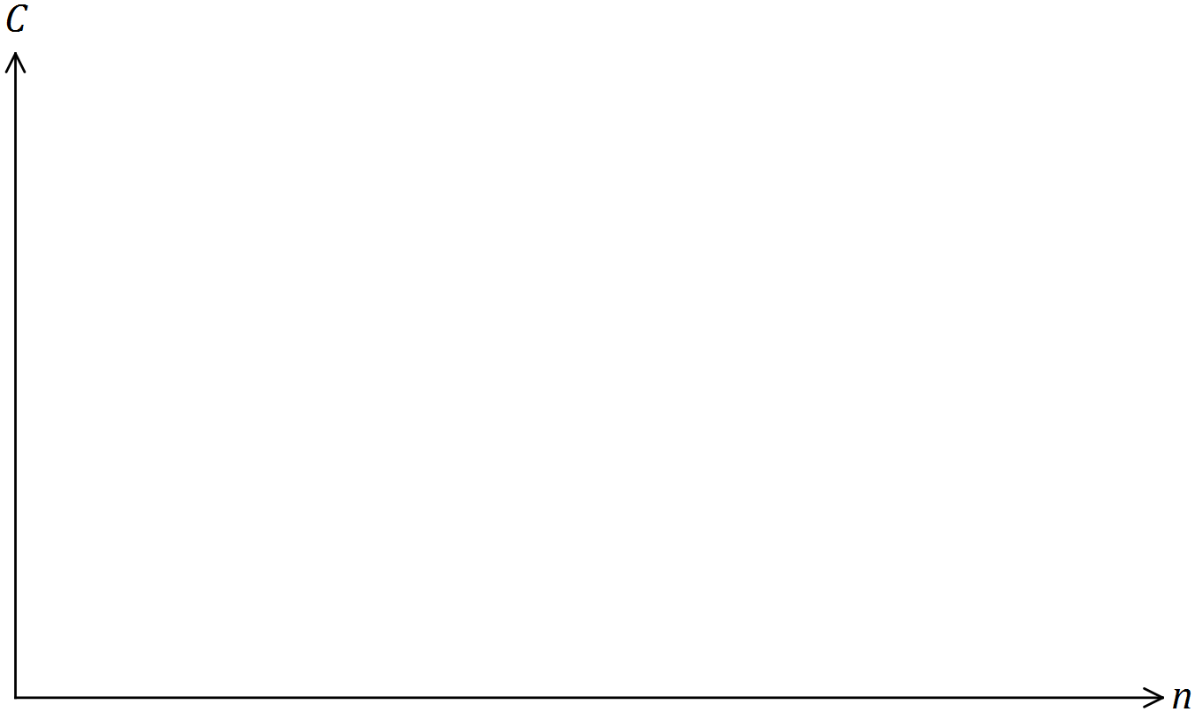

(b) The variables $A$ and $n$ are inversely proportional to each other, so that when $n=10$, it is known that $A=60$.

(i) Write an equation that relates $A$ and $n$. (2 marks)

(ii) Determine the value of $n$ when $A=15$. (1 mark)

Question 10 (6 marks)

(a) The parabolic graph of a relation is shown below.

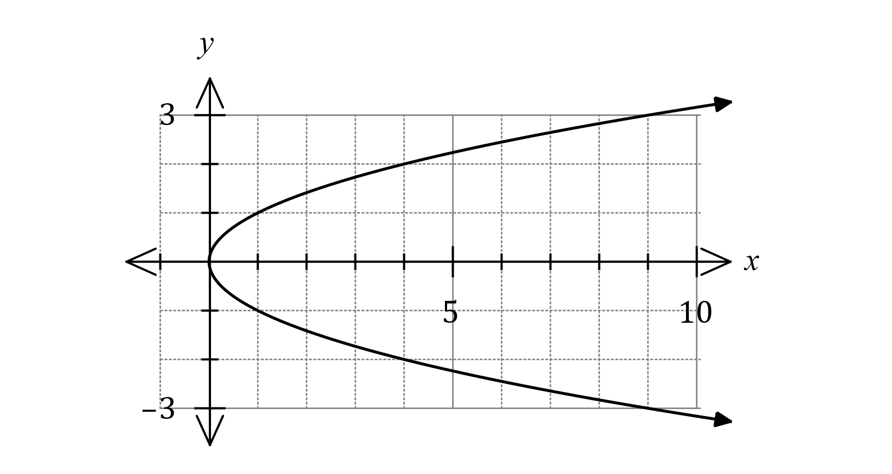

(i) State the equation of its axis of symmetry. (1 mark)

(ii) State the equation of the relationship between $x$ and $y$. (1 mark)

(b) Points $A$ and $B$ have coordinates $(7, 8)$ and $(-3, 2)$ respectively. Determine the equation of the circle that has diameter $AB$. (4 marks)

Question 11 (8 marks)

(a) At 3 pm, the length of the shadow of a thin vertical pole standing on level ground is the same as the height of the pole. A while later, the angle of elevation of the sun has decreased by 12° and the length of the shadow has increased by 95 cm. Determine the height of the pole. (4 marks)

(b) A windscreen wiper on a car is 43 cm long and rotates through one-third of a circle, as shown below. The inner and outer radii of the arcs are 20 cm and 63 cm. Determine the shaded area, rounding your answer to a reasonable degree of accuracy. (4 marks)

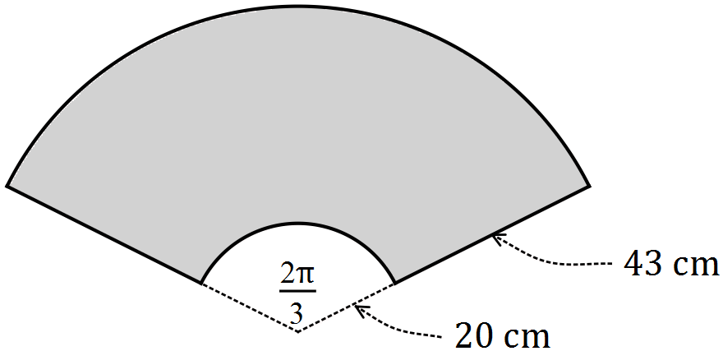

Question 12 (8 marks)

(a) Triangle $ABC$ is such that $b=15$ cm, $c=18$ cm and $∠A=125°$. Determine, with justification, the length of side $a$. (2 marks)

(b) Triangle $PQR$ is such that $p=48.1$ cm, $q=41.5$ cm and $∠Q=45°$. Determine all possible areas of this triangle. (6 marks)

Question 13 (8 marks)

Let $f\left(x\right)=2\sqrt{4-x}-2$.

(a) Sketch the graph of $y=f(x)$ on the axes below. (4 marks)

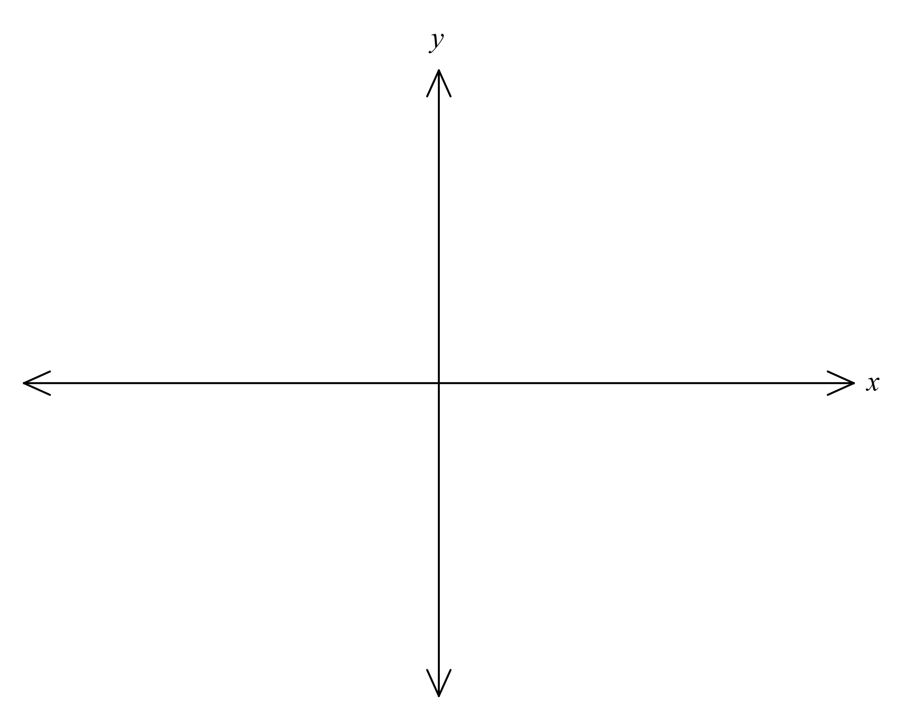

(b) Describe the transformation(s) required to obtain the graphs of the following functions from the graph of $y=f(x)$:

(i) $y=2\sqrt{1-x}-2$. (2 marks)

(ii) $y=\sqrt{4-x}-1$. (2 marks)

Question 14 (8 marks)

(a) The graph of $y=2x^{2}+bx+16$ has a line of symmetry with equation $x=3$.

(i) Determine the value of $b$. (2 marks)

(ii) Draw the graph of the parabola on the axes below. (3 marks)

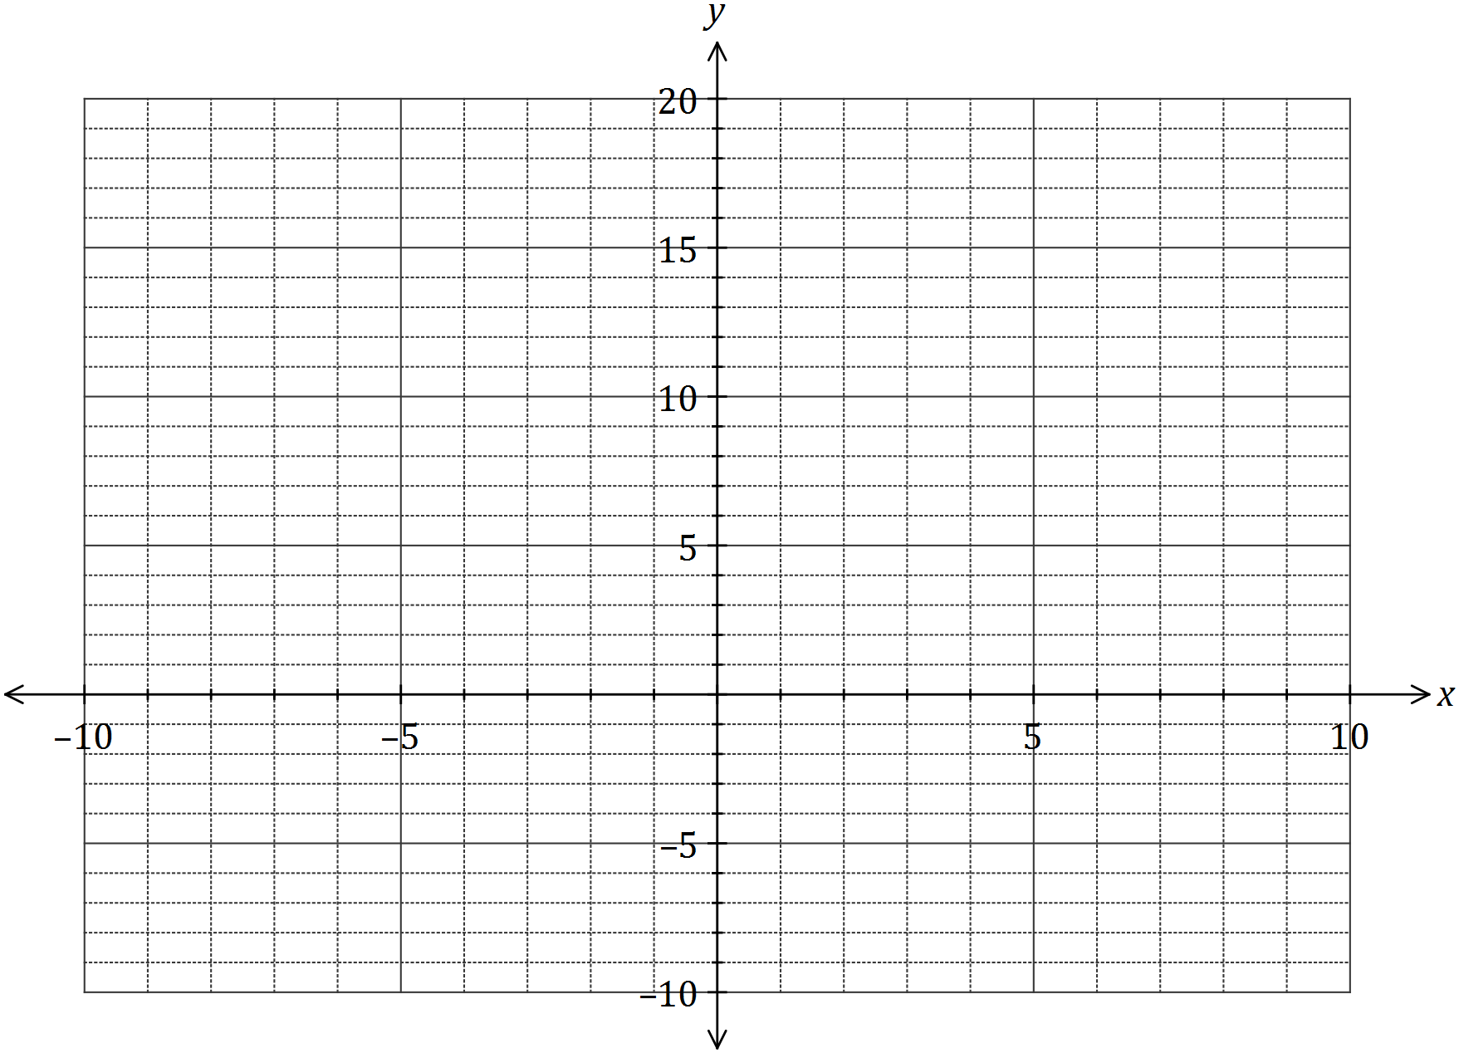

(b) One of the solutions to the equation $2x^{3}+21x^{2}+cx-495=0$ is $x=5$. Determine the value of $c$ and all other solutions. (3 marks)

Question 15 (9 marks)

The loudness $L$ of sound, in decibels, emitted by a machine $t$ minutes after it is switched on can be modelled by

$$L=55-8\cos\left(\frac{πt}{15}\right)$$

(a) Determine the initial loudness emitted by the machine. (1 mark)

(b) Draw the graph of $L$ against $t$ on the axes below for the first $90$ minutes. (3 marks)

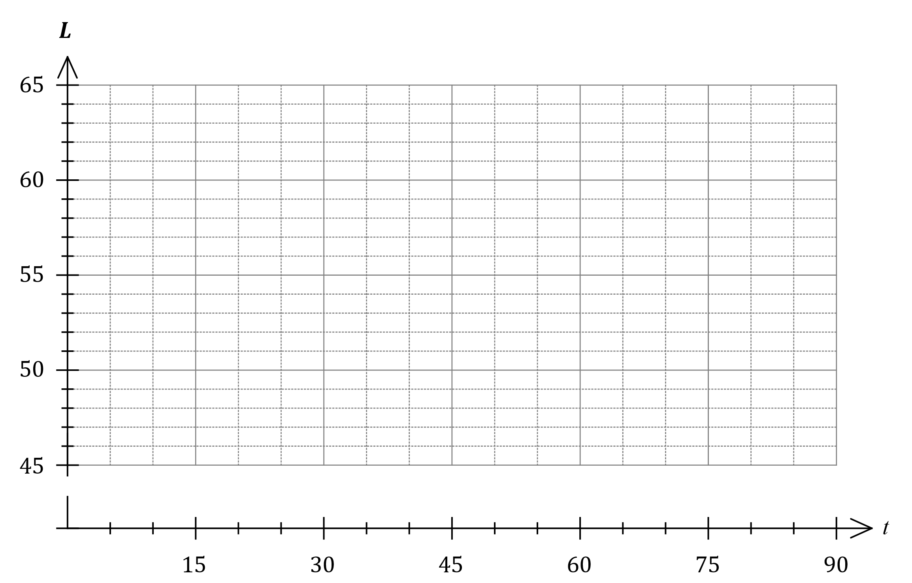

(c) State the maximum loudness emitted by the machine and the time this maximum was first reached. (2 marks)

(d) A health and safety inspector can deem a machine unserviceable if the loudness it emits exceeds $60$ dB for more than $15$ minutes in any hour that it is running. Determine, with justification, whether this machine could be deemed unserviceable. (3 marks)

Question 16 (8 marks)

(a) Let $f\left(x\right)=x^{2}+bx+c$, where $b$ and $c$ are constants. The graph of $y=f(x)$ has an axis of symmetry with equation $x=-3$ and an axis intercept at $(0, 5)$.

Determine the value of *f (1).* (3 marks)

(b) Let $g\left(x\right)=2{\left(x-2\right)}^{2}-7$. Determine

(i) the coordinates of the turning point of the graph of $y=g(x)$. (1 mark)

(ii) the domain and range of $g(x)$. (2 marks)

(iii) the coordinates of the turning point of the graph of $y=g\left(x-3\right)+2$. (2 marks)

Question 17 (8 marks)

(a) On the axes below, draw the graph of $y=\tan\left(\frac{x}{3}\right)$ over the interval $0≤x≤5π$, clearly indicating the equations of any asymptotes. (3 marks)

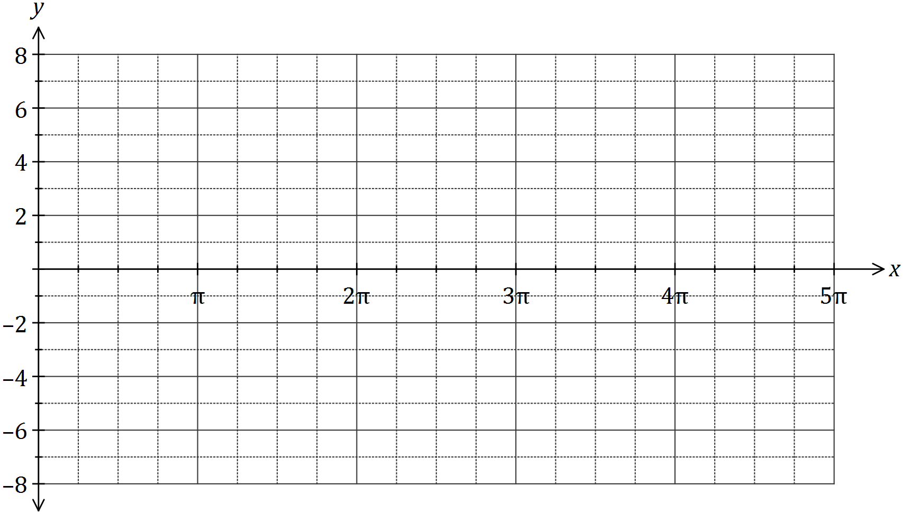

(b) Solve the following equations over the interval $0≤x≤5π$.

(i) $\tan\left(\frac{x}{3}\right)=-1$. (1 mark)

(ii) $\tan\left(\frac{x}{3}\right)-\sqrt{3}=0$. (2 marks)

(c) Determine the smallest positive value of $α$ so that $\tan\left(x-\frac{5π}{6}\right)=\tan\left(x+α\right)$. (2 marks)

Question 18 (7 marks)

The equation of a parabola is $y=\begin{matrix}1 \\ \overline{4}\end{matrix}(x^{2}-6x+15)$.

(a) Sketch the parabola on the axes below. (3 marks)

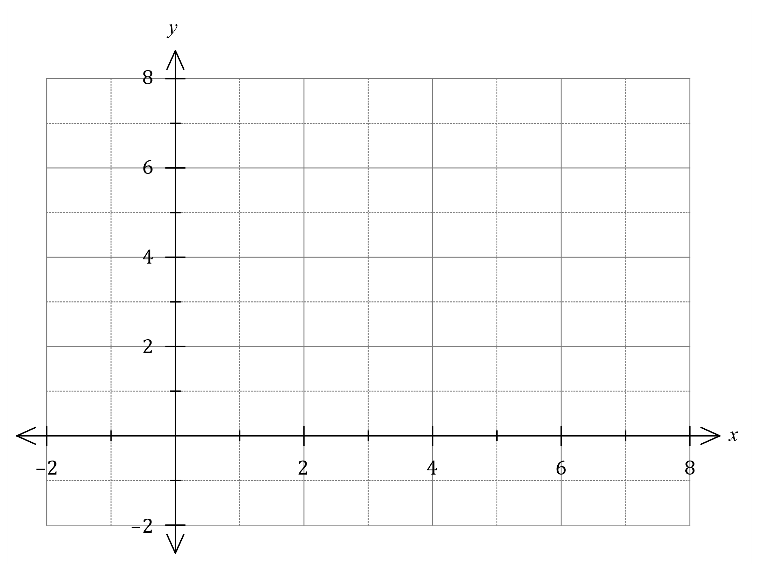

All parabolas have a focal point and a directrix. For a parabola with equation $y=a{\left(x-p\right)}^{2}+q$, the focal point is at $\left(p, q+\begin{matrix}1 \\ \overline{4a}\end{matrix}\right)$ and the equation of the directrix is $y= q-\begin{matrix}1 \\ \overline{4a}\end{matrix}$, where $a, p$ and $q$ are constants.

(b) Determine the focal point and directrix for this parabola and add them, with labels, to your sketch above. (4 marks)

Question 19 (8 marks)

(a) Using the unit circle shown, determine the following in terms of $a$ and/or $b$, given that $θ$ is an acute angle measured in degrees.

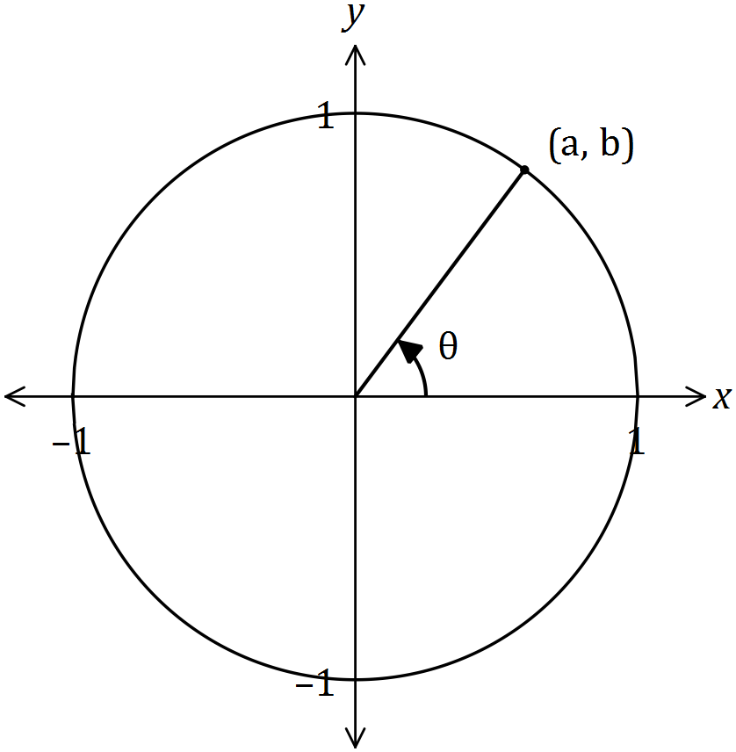

(i) $\sin\left(θ\right).$ (1 mark)

(ii) $\cos{(180-θ)}$. (1 mark)

(iii) $\tan{(90+θ)}$. (1 mark)

(b) Determine $x$ in each of the following cases, where $0≤x≤\frac{π}{2}$.

(i) $\sin{x}=\sin{17π}$. (1 mark)

(ii) $\cos{x}=\cos{ }\frac{23π}{6}$. (1 mark)

(c) Draw the graph of the relation ${x^{2}+y}^{2}=2x-6y+26$. (3 marks)

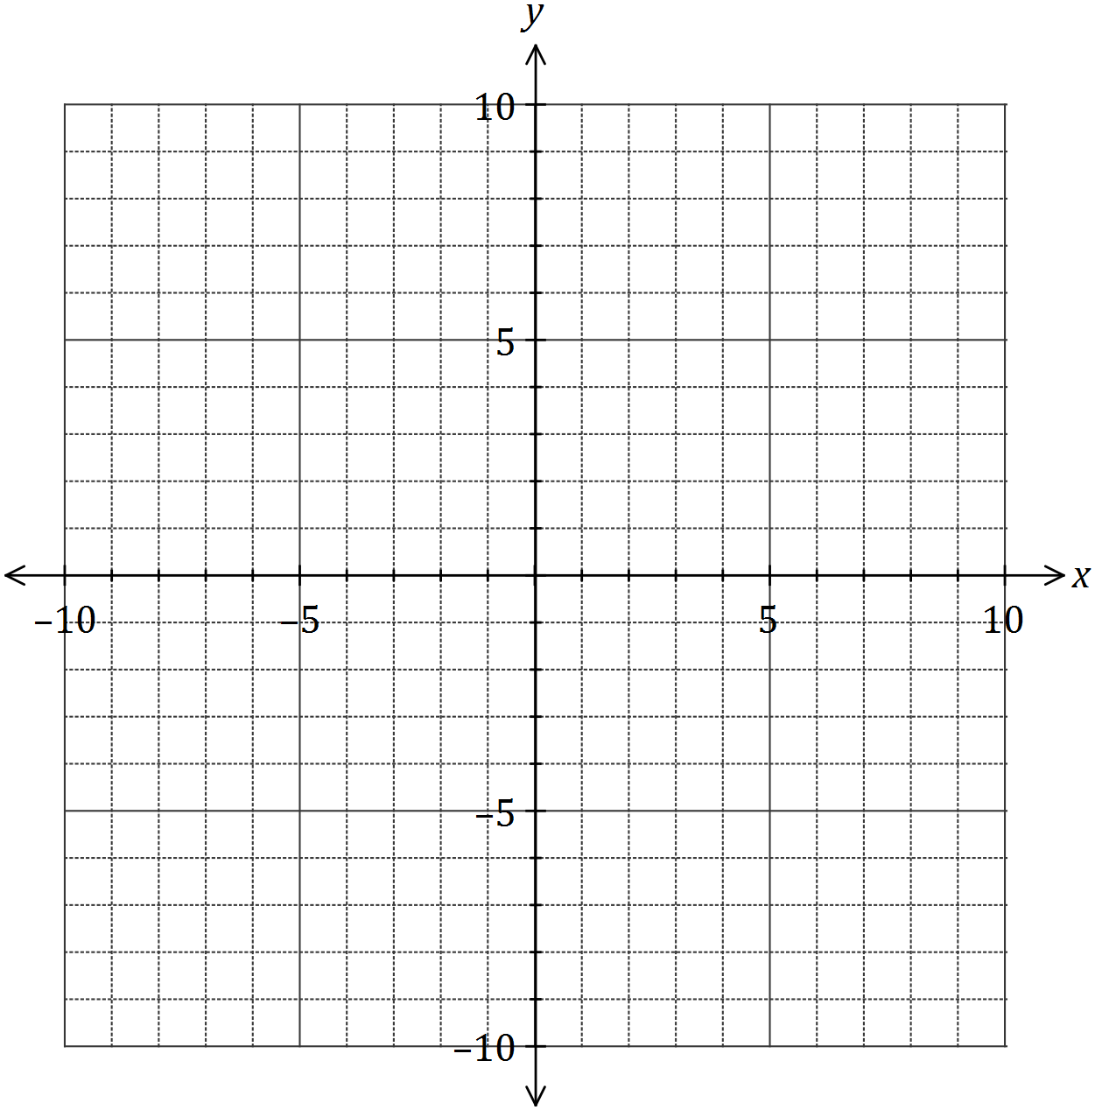

Question 20 (7 marks)

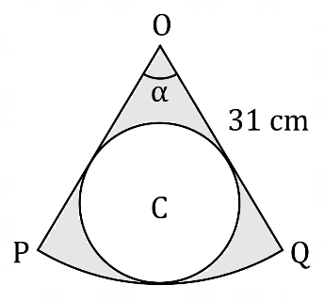The diagram shows sector $OPQ$ of a circle  
centre $O$ of radius $31$ cm and $α=40°$.

Circle $C$ is inside the sector and just  
touches $OP, OQ$ and arc $PQ$.

(a) Determine the area of sector $OPQ$. (2 marks)

(b) Show that the radius of circle $C$ is $7.9$ cm, correct to one decimal place. (3 marks)

(c) Determine the area of the shaded region, inside sector $OPQ$ but outside circle $C$.

(2 marks)

Question 21 (7 marks)

The equation $f\left(x\right)=k$ has two solutions, where $f\left(x\right)=ax^{3}+bx^{2}-12x+8$ and $a, b$ and $k$ are constants.

The graph of $y=f(x)$ cuts the $x$-axis at $x=2$, $x=-2$, and at one other point.

Determine the value(s) of the constant $k$, rounded to $2$ decimal places. Explain your reasoning.

Supplementary page

Question number: _________

Supplementary page

Question number: _________

© 2021 WA Exam Papers. Kennedy Baptist College has a non-exclusive licence to copy and communicate this document for non-commercial, educational use within the school. No other copying, communication or use is permitted without the express written permission of WA Exam Papers. SN245-172-2.